Experiment 9

Aim: To implement image scaling techniques in Python using OpenCV to resize an image to both larger and smaller dimensions.

Algorithm:
- Import the OpenCV library.
- Read the input image.
- Resize the image to a larger size using cv2.resize().
- Resize the image to a smaller size using cv2.resize().
- Display the original, enlarged, and reduced images.
- Close all display windows.

Program
import cv2
img = cv2.imread("image.jpg")
bigger = cv2.resize(img, None, fx=2, fy=2)
smaller = cv2.resize(img, None, fx=0.5, fy=0.5)
cv2.imshow("Original Image", img)
cv2.imshow("Bigger Image", bigger)
cv2.imshow("Smaller Image", smaller)
cv2.waitKey(0)
cv2.destroyAllWindows()
Output
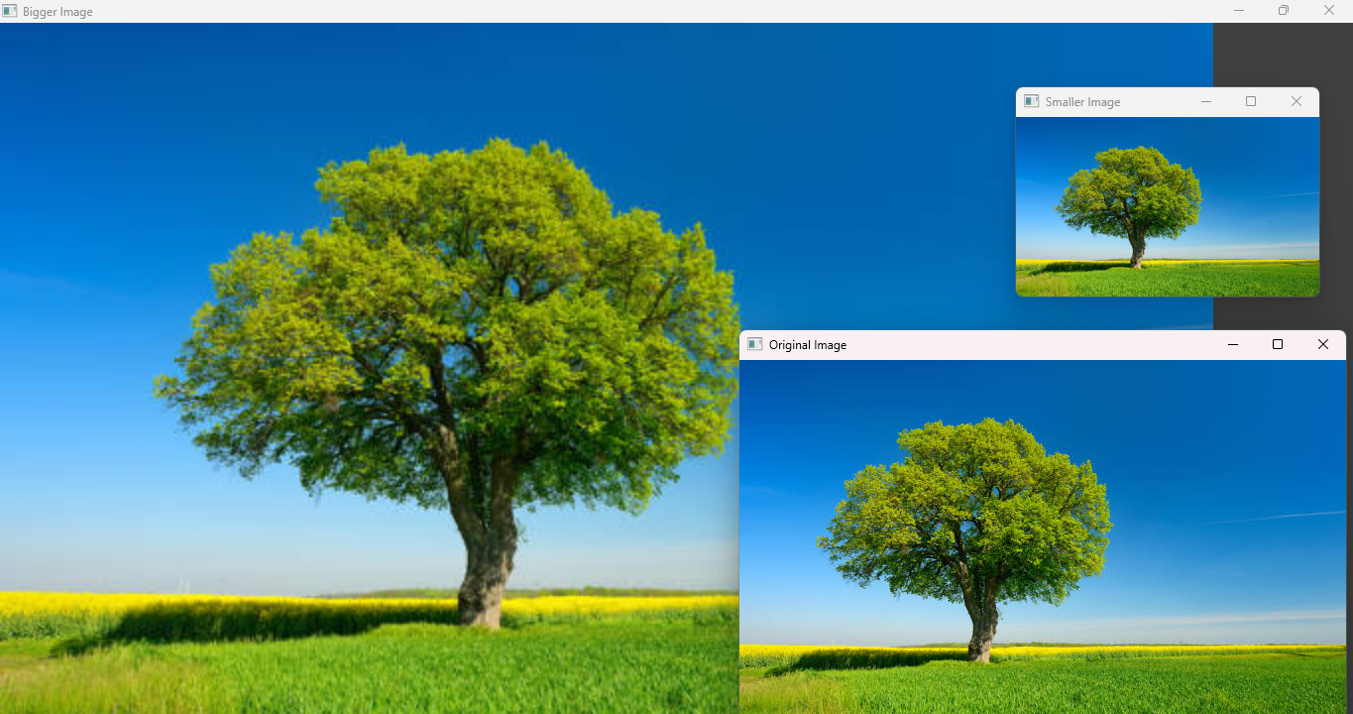

Result: Thus, image scaling was successfully implemented using OpenCV to enlarge and reduce the dimensions of the given image.

